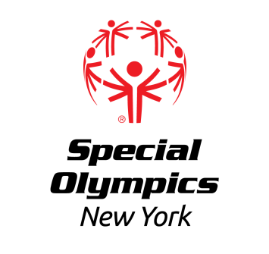

North Country Region

Singles and Unified Doubles

Bowling Competition

**Sunday December 15th, 2024**

**LOCATION:** North Bowl Lanes

28 N Bowl Ln

Plattsburgh, NY 12901

**REGISTRATION:** This event offers competition for athletes that have been training in Bowling.

**In order to register for this event, each training club MUST have a current roster on file with the Regional Office. Please contact ekromer@nyso.org or *(518) 388-0790 ext 8131* if you need to update your roster.**

**Registration forms for athletes and coaches should be submitted no later than** **Wednesday December 4th, 2024** to Erik Kromer by ***fax at (518) 612-4060*** or ***email at*** [***ekromer@nyso.org***](mailto:ekromer@nyso.org). All registered athletes must have a current medical and consent and all registered coaches must be up to date and certified Special Olympics Coaches.

**AREAS/REGIONS:** North Country Training Clubs are invited to participate.

**AWARDS:** Athletes will be awarded ribbons.

**EVENT SCHEDULE:**

*(Subject to change)*

930-10:15 am Athlete Registration

Volunteer Registration

10:20 am Coaches Meeting

10:35 am Opening Ceremonies

10:45 am Athlete Warmups

Competition

Awards at conclusion of Event

**Food will not be provided** **at this event.  
Concessions are available.**

**Please ensure athletes are not eating while competing.**