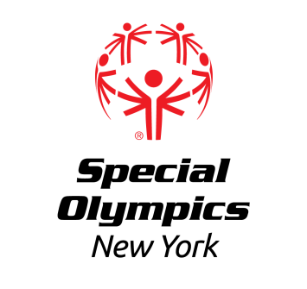

Capital District Region

Regional Team and Unified Team Bowling Competition
Sunday March 24th, 2024

LOCATION: King Pin’s Alley Family Fun Center
166 Saratoga Ave
South Glens Falls, NY 12803

REGISTRATION: This event offers competition for athletes that have been training in Bowling.

In order to register for this event, each training club MUST have a current roster on file with the Regional Office. Please contact ekromer@nyso.org or (518) 388-0790 ext 8131 if you need to update your roster.

Registration forms for athletes and coaches should be submitted no later than Wednesday March 13th, 2024 to Erik Kromer by fax at (518) 612-4060 or email at ekromer@nyso.org. All registered athletes must have a current medical and consent and all registered coaches must be up to date and certified Special Olympics Coaches.

AREAS/REGIONS: Capital District and North Country Training Clubs are invited to participate.

AWARDS: Athletes will be awarded medals or ribbons, depending upon place.

DIRECTIONS: Northbound: Take I-87 to Exit 17. Merge onto Route 9. Destination is on the left. Southbound: Take I-87 to Exit 18. Continue on Main St/Broad St. Take the first exit at the circle onto Main St./US-9. Destination is on the right.
EVENT SCHEDULE
(Subject to change)

12:30 -1:00 pm Athlete Registration
Volunteer Registration

1:15 pm Coaches Meeting

1:30 pm Opening Ceremonies

1:40 pm Athlete Warmups
1:45 - 3:30 pm Competition
Awards at conclusion of Event

Food will not be provided at this event.

