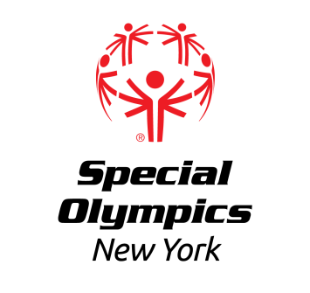

Capital District Region

Aquatics Competition

Saturday, April 27, 2024

LOCATION: Mohonasen High School, Pool
2072 Curry Road
Schenectady, NY 12303

REGISTRATION: In order to register for this event, each training club MUST have a current roster and ALL waivers and certifications on file with the Regional Office.

Registration forms for both athletes and coaches should be submitted no later than Thursday, April 18th to Erik by fax at (518) 930-4884 or email at ekromer@nyso.org All registered athletes must have a current medical and consent and all registered coaches must be certified Special Olympics Aquatics Coaches.

AREAS/REGIONS: All Training Clubs are invited to participate.

AWARDS: Athletes will be awarded ribbons depending on place.

MEALS/CONCESSIONS: Not provided at this event

EVENT SCHEDULE
(subject to change)

1:00pm Arrival/Registration
Volunteer Registration

1:50pm Opening Ceremonies

2:00pm Coaches Meeting

2:10pm Warm Ups
Competition begins immediately after
Participants awards on the deck following each race

