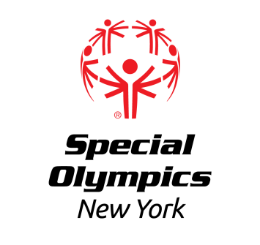

Capital District Region

Regional Bowling Competition

Singles and Ramp Singles
Sunday November 4th, 2024

LOCATION: Saratoga Strike Zone
32 Ballston Ave
Saratoga Springs, NY 12866

REGISTRATION: This event offers competition for athletes that have been training in Bowling.

In order to register for this event, each training club MUST have a current roster on file with the Regional Office. Please contact ekromer@nyso.org or (518) 388-0790 ext 8131 if you need to update your roster.

Registration forms for athletes and coaches should be submitted no later than Friday October 11th, 2024 to Erik Kromer by fax at (518) 612-4060 or email at ekromer@nyso.org. All registered athletes must have a current medical and consent and all registered coaches must be up to date and certified Special Olympics Coaches.

AREAS/REGIONS: Capital District and North Country Training Clubs are invited to participate.

AWARDS: Athletes will be awarded medals or ribbons, depending upon place.

DIRECTIONS: Take I-87 to Exit 13N. Continue north on Route US-9 for 7 miles. Turn left onto Lincoln Ave, then right to Saratoga Strike Zone on your right. Entrance and parking lot facing Ballston Ave.
EVENT SCHEDULE
(Subject to change)
a Sunday 10:15am bowling start, so staff arrival at 830, a 9-930 athlete registration, 950 Opening ceremony, 10:05 warmup
9-9:30 am Athlete Registration
Volunteer Registration

9:35 am Coaches Meeting

9:50 am Opening Ceremonies

10:05 am Athlete Warmups
10:15 am- 1:00 pm Competition
Awards at conclusion of Event

Food will not be provided at this event

