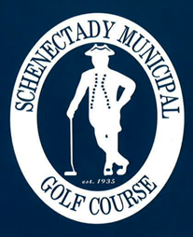
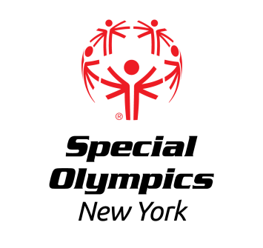

Capital District

Regional Golf Competition
Friday August 18th, 2023
https://muni.golf/

**Please see second page for scorecard and layout of course**

LOCATION: Schenectady Municipal Golf Course
400 Oregon Ave
Schenectady, NY 12304

REGISTRATION:
This event offers competition for athletes that have been training in Alternate Shot and Individual Stroke Play. This event will provide the use of a golf cart; however, participants should be prepared to share the cart with another delegate.

In order to register for this event, each training club must have a current roster and medical and consents on file with the Regional Office. Please contact Erik Kromer at ekromer@nyso.org (518) 388-0790 ext. 8132 if needed.

Registration forms for athletes, partners and coaches must be submitted no later than Friday, August 4th, 2023 to Erik Kromer by fax at (518) 612-4060 or email at ekromer@nyso.org. All registered athletes must have a current medical, consent, and COVID paperwork, all partners (alt shot participants) must be registered class A volunteers or registered SONY partners, and all registered coaches must be certified Special Olympics Coaches.

REGIONS: All Regions and Training Clubs are invited to participate, with priority to Capital District and North Country Training Clubs.

AWARDS: Athletes will be awarded medals or ribbons, depending upon place.

EVENT SCHEDULE: (subject to change)
**Putting green and driving range will be available prior to play**

10:00-10:30 am---Athlete Registration and Volunteer Registration

10:35 am---Opening Ceremonies

11:00 am—Coaches Meeting

11:20 am—Competition; First tee time at 11:30am
Following tee times at 9-minute intervals (as per course rules)

Awards at conclusion of Event

Light meal after competition to be provided

