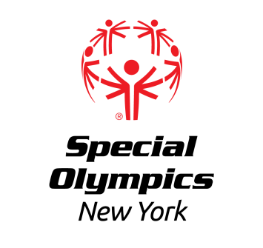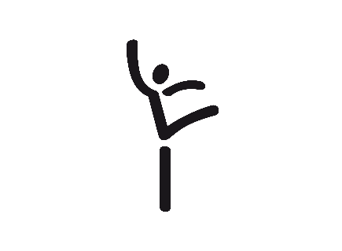

Capital District Region

Gymnastics Invitational
Sunday, May 21st, 2023

LOCATION: World Class Gymnastics
630 Columbia St Ext #1
Latham, NY 12010
We will utilize both the front and back gym for competition

REGISTRATION: In order to register for this event, each training club should have a current roster on file with the Regional Office. Please contact Erik at ekromer@nyso.org or at 518-612-4060

Registration forms for both athletes and coaches should be submitted no later than Wednesday, May 10th, 2023 to Erik Kromer by fax at (518) 612-4060 or email at ekromer@nyso.org. All registered athletes must have a current medical, consent, and paperwork and all registered coaches must be certified Special Olympics Coaches accredited in Gymnastics.

AREAS/REGIONS: This is an invitational event for all interested Gymnastics teams

MEALS: FOOD/LUNCH WILL NOT BE PROVIDED

AWARDS: Athletes will be awarded at the conclusion of the event

EVENT SCHEDULE
(subject to change)

12:45-1:15pm Arrival/Registration
1:15pm Coaches Meeting
1:30pm Opening Ceremonies
1:45pm Competition Begins
Most Mens events are offered in the back gym
Most Women’s events offered in the front gym

