Bowling Tournament

**(ALL AGES)**

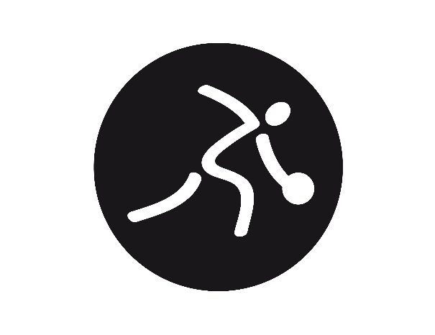

**Saturday, June 3rd, 2023**

**Bowlero Sayville**

5660 Sunrise Hwy

Sayville, NY 11782

**Registrations Due:**

**Friday, May 19th 2023**

(Registration Form is separate)

|  |
| --- |
| **Fax or Email:**  **Emmanuel Lindsay**  **Email:** [elindsay**@nyso.org**](mailto:elindsay@nyso.org)  **Phone: (646) 893-6219** |

**Important Information – Please Read Carefully!!**

Fill out the registration form and return it as soon as possible. All athletes must have a current medical and consent form on file with the Special Olympics New York Long Island Region office in order to compete.

**Each coach is required to submit a *FULL* team**

**Roster when you register**

(Registration Form is separate)

Any questions regarding the medical & consent forms,

Registration, or bowling competition

Please call the Special Olympics New York office at:

Phone: (212) 661-3963 x 2216

**ATTIRE:**

Athletes must wear appropriate clothing to train and compete successfully. Inappropriate clothing can impact an athlete’s ability to bowl and, in some cases, may be a safety hazard.

At local competition, all athletes **must** wear a shirt with a butterfly-type collar (polo shirt). Bowlers will be allowed to wear sweatpants, as long as they are neat, clean, and in good condition. Golf-style shorts are acceptable, but bowlers are not permitted to wear basketball/gym shorts. Bowlers are not permitted to wear hats. All teams should dress in matching shirts and matching colored pants.

At the state level, bowlers will be expected to wear casual slacks or trousers- no sweat pants (with or without elastic cuffs), gym shorts, skirts, or skorts will be permitted.

**NO JEANS/DENIM WILL BE PERMITTED**

**EVENTS OFFERED:**

* **SINGLES** 
  + You may register your athletes for singles competition, but they will not be eligible for State Games
* **RAMP Singles**
  + You may register your athletes for ramp singles, but they will not be eligible for State Games
* **TEAM BOWLING** (for those interested in attending Summer State Games)
  + SONY will be offering **TEAM BOWLING ONLY** at State Games**.**
  + Please register teams of 4.

**\* In order to be able to compete in the Special Olympics New York Long Island Region Bowling Competition, the bowler *MUST* participate in a program under the supervision of a certified coach prior to the competition.**

If a bowler uses a ramp, the ramp will be provided (be sure to check off ramp on the registration form)

**THE CUT-OFF DATE FOR REGISTRATION IS:**

**Friday, May 19th,2023**

**REGISTER TODAY!!**

Registration forms received after

Wednesday May 4th will ***NOT*** be accepted.

Please register early!

**SPECIAL OLYMPICS NEW YORK**

**560 Broadhollow Rd.**

**Suite 106**

**Melville, NY 11747**

*Attention:*

Emmanuel Lindsay

[elindsay@nyso.org](mailto:elindsay@nyso.org)

Associate Director of Program

Bowling Tournament

(ALL AGES)

**Saturday, June 3rd, 2023**

**SCHEDULE OF EVENTS**

|  |  |  |
| --- | --- | --- |
| 10:00 am |  | Coaches Check-In |
| 11:00 am |  | Opening Ceremonies |
| 11:30 am |  | Competition Begins |

** Please notice opening ceremonies is scheduled for 11:00 am**

MC900290914[1]**Bowlero Sayville**

**5660 Sunrise Hwy  
Sayville, NY 11782**

**Phone: (631) 567-8900**

**Lunch will *NOT* be provided.**

**NO outside food will be permitted.**

**The house will have their snack bar available for purchase.**