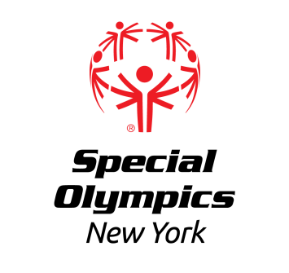

Capital District Region

Local Basketball Team and Skills Competition
Sunday, April 16th, 2023

LOCATION: RPI- East Campus Athletic Village (ECAV)
Peoples St.
Troy, NY 12180

REGISTRATION: In order to register for this event, each training club MUST have a current roster on file with the Regional Office.
Registration forms for both athletes and coaches should be submitted no later than Friday, March 31st to Erik Kromer by fax at (518) 612-4060 or email at ekromer@nyso.org. All registered athletes must have a current medical and consent and all registered coaches must be certified Special Olympics Coaches, and the head coach for each team must be certified in Basketball.

AREAS/REGIONS: All Regional or Area Training Clubs are invited to participate, with preference to Capital District Region Clubs if spots are limited. If there are not sufficient skills registrants, skills may be canceled.

AWARDS: Athletes will be awarded ribbons.

DIRECTIONS: From I87, take exit 7 and proceed East on Rte 7. When you cross over the Hudson River, Rte. 7 becomes Hoosick St. Take a right on Burdett Ave. Go to 2nd Stoplight and take a left on Peoples Ave. Follow Peoples Ave to the right around the Hockey Arena. Park in lot D which will be on your left.

EVENT SCHEDULE
(subject to change)

9:00am Arrival/Registration
Volunteer Registration

9:40am Opening Ceremonies

10:00am Pairing Games

11:00am Competition begins
Awards to follow

